Home learning ideas Chomp
Choose a task for each week of the term. We want you to be engaged with your homework so there is a lot of choice for you. You can either share your work electronically (email to s.digiorno@wroxtonprimary.co.uk )or add to your homework book.
Invent a Tooth Hero or Villain Create your own superhero or villain linked to teeth or digestion! For example, a superhero who protects teeth from plaque or a villain who loves sugary snacks. Draw your character and write a short profile explaining:  - Their special powers.  - Their strengths and weaknesses.  - How they help (or harm) our teeth  - A fun fact or catchphrase. | Cooking  Bake with a family member and share with your family. Ask them for feedback. Send us a photo of your dish. | Growth mind-set  What sort of things can you do now that you couldn’t when you were younger?  Was it always easy to learn to do those things?  What did you have to do in order to make it easier?  What would you like to improve at now? | French – practise saying what you do.  Je peux…  . 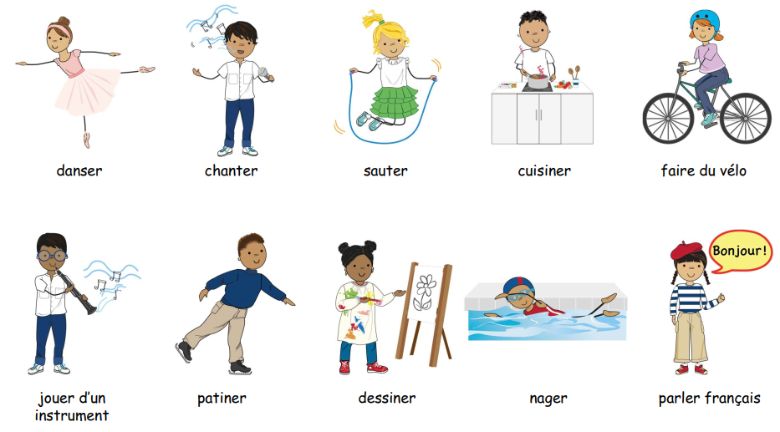
Digestive system  Could you make a model of your teeth or one of the organs the digestive system? |   Fair Trade  Learn about Fair Trade and look for this logo when you go shopping. What products feature the logo? | Get active!  Try some of these ways of getting active  From the ‘NHS Healthier families’ website. You'll find lots of ideas that you can do with family members - or change them a bit to do by yourself, if everyone is busy! Remember - keeping physically fit helps your brain to be fit, too! | Free choice  You can choose a creative project linked to our topic that you are interested in
Create an animal fact file  Choose an animal that interests you and create an exciting fact file explaining how its teeth help it survive.  Your fact file should include  Name and a picture or drawing.  Where it lives (its habitat).  What it eats  What its teeth look like and how they help it eat its food.  Fascinating facts about the animal. | Packaging Choose a packet of biscuits from and investigate its packaging. Think about:  - What is the name of the biscuit?  - What colours, pictures and fonts have been used?  - Who do you think the biscuits are aimed at (children, adults or families)?  - What information can you find on the packaging? (e.g. ingredients, nutrition, allergy advice etc) | Healthy body  Can you think of five snacks that you could have at break or after school? Make a list and set yourself a challenge to try something new. | RWV – What kind of world did Jesus want?  Create a seven-day kindness calendar. Complete one act of kindness each day and decorate your calendar with drawings or photos.

